Winter 2022
Snyder-Lewis-Welty
Post 454
Colon Michigan

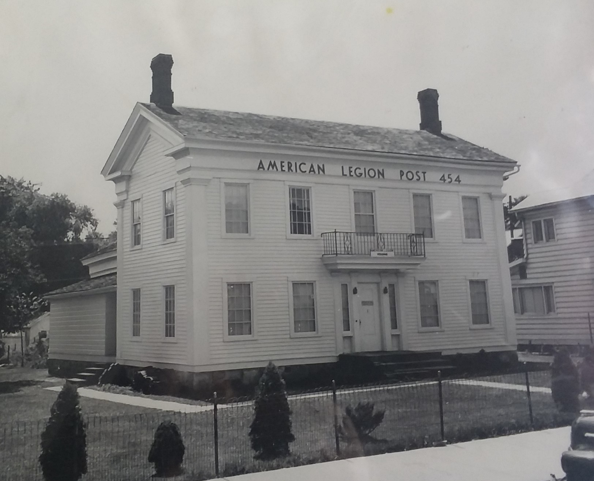

Hello Everybody,
Well, it is once again time for your twice yearly (semi-annual, biannual…I can never remember which one means twice a year and which one means every two years so twice yearly it is) newsletter. With the continued easing of COVID restrictions it has been a busy second half to 2021.

August was a hectic month for us, starting with Magic Week. Abbott’s once again held their Get Together and with pent-up demand from no convention the year prior, Colon was packed with a plethora of prestidigitators! That meant great business for the bar. We count on Magic Week to cover all of our insurance requirements (and there are many and they are expensive) for the year. This year did not disappoint and the club was full for three nights.

Also in August was our big event of the year, the Magic City Egg Fest. According to EGG-secutive Director and SAL member Tim Taylor, “More than 700 attendees feasted on ribs, chicken, and wood fired pizzas from 25 culinary teams who competed in three rounds of cooking…” Cooking was done on the Big Green Egg, all of which were provided by our primary sponsor for the event, Hastings Area Ace Hardware. Additionally, 29 teams participated in the Pioneer Seed sponsored Corn Hole Tournament. The event raised over $7,000 for the Post. You can read more about this event on our website under the News section. This year’s date has been set for August 13. Watch our website for developing information and get your team together to compete!

Additionally in August we served as a stop for two motorcycle Poker Runs, hosted lunch for two tour groups who came to town for magic shows, and restarted our monthly fish fry. Throughout the course of fall Legionnaires raised the flag at all of the home games for the State Runner Up Championship, Magi Football Team. We had several post parties including our Halloween Costume Party, our Membership Appreciation Party and our Ugly Sweater Party. All were thoroughly enjoyed with prizes and raffles during the evening.
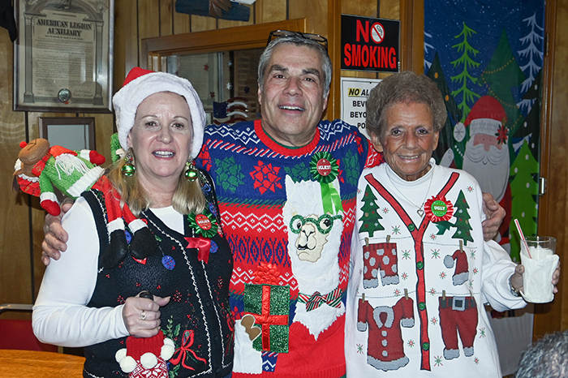

On Halloween we passed out 50 cent pieces to over 350 Trick-or-Treaters and on December 18 over 75 kids came and visited Santa Clause and received a free gift. Speaking of the Children’s Christmas Party, I was overwhelmed by your participation in our sweepstakes last fall. Your generosity completely covered the cost of this year’s gifts for the kids. Thank you so much for your contributions.
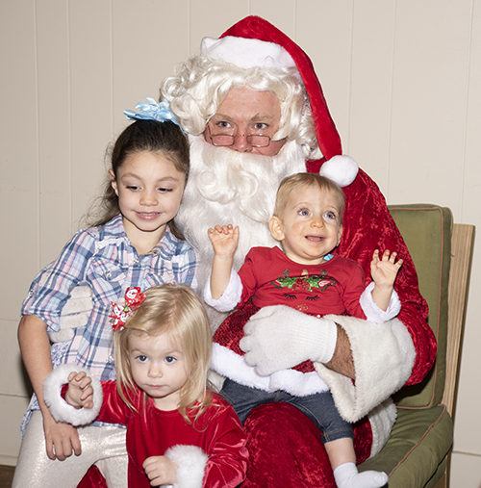

Our Veteran’s Day Ceremony was held at the Post on November 11 with veterans, Auxiliary and SAL members present as well as members of the community. While we had hoped to once again hold this event at the school issues with COVID and the administration frustrated our attempts.

December started with Christmas in Colon. The Legion Color Guard led the evening Christmas Parade. The Post also held a Chili Cookoff which saw 11 entrants and more than 90 chili tasters. Cash prizes were awarded for first, second and third place with all winners donating the winnings back to the Post.

Throughout, Snyder-Lewis-Welty Post has continued to demonstrate that we are the premier service organization in the community. We provided financial support to the football and volleyball team. We hosted two Bingo Nights for the baseball team; their primary fundraising activity. We have provided financial support to struggling veterans of the community, helping with automotive repairs, medical bills and other needs. We also provided baked goods and a check for $300 to Miss Sawyer’s Kids With A Cause who sent care packages to deployed troops. The Auxiliary and Sons also each provided checks of $300 to this worthwhile organization.

Our Queen of Hearts Raffle is doing very well. Just after our last newsletter someone won the jackpot and received over $7,000. The current jackpot, as of this writing, is over $45,000 and expected to hit $50,000 by Saturday night when the next card is drawn. Not only is this raffle bringing in money for the park, but it is bringing in people to the bar and raising our revenue there. Again, all of the proceeds from this raffle go to the construction of Veterans Memorial Park. Our weekly Bingo continues to be well attended. With all of this going on I am happy to report to you that our Post is financially strong which enables us to do the good work that we do here in the community.

Our financial stability also allows us to maintain our facilities. As I mentioned in our last newsletter, the barn was going to get a new roof. That project is completed and the roof looks great. Now we need a new roof over the 1966 addition on the front of the building and over the kitchen. We have had a couple of contractors come in to work up bids for us and hopefully by the next newsletter I’ll be able to report completion of that project. We are also continuing to move forward on renovation of the interior of the building. We hope by summer to have architectural plans complete so that we can apply for a building permit and commence updating our 1960’s look to something a little more contemporary.
With all this exciting stuff going on, our Post is growing. As I reported in the last newsletter, we had 115 Legion members for the year which ended June 30, 2021. Our goal for this year is 118 and right now we are again at 115. So, if you have still not sent in your dues for this year, please do so and help us exceed our goal again this year. The Auxiliary has a goal of 84 and are currently at 77. They too need you to send in your dues. The big winner of the family though is the Sons with a goal of 65 they are at 77 for 118% of goal and there are still a couple of memberships that we have to get sent in to Department! Congratulations SAL! If you know someone who is eligible for membership in the Legion, Auxiliary or SAL---SIGN THEM UP!

This year marks the 75th Anniversary of the granting of our permanent charter for Snyder-Lewis-Welty Post 454. On March 11, 75 years to the day that the charter was granted, we will be holding our Legion Birthday Party. We expect a full house so reservations are a must. There will be a sign-up sheet in the Legion from February 18 through March 3. It is imperative that you sign up if you are coming so that the Auxiliary can plan accordingly. If you can’t make it in to sign up in person, call the post during business hours and the bartender can sign you up. Cocktail/social hour will begin at 6:00 PM with dinner to follow at 7:00. I hope to see you there.
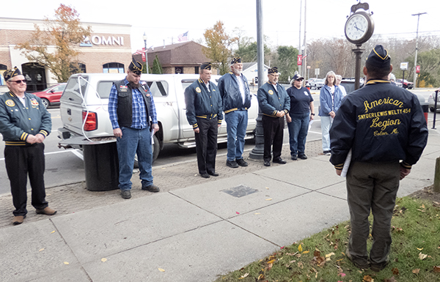

As we head into spring and summer (I know its still 15 degrees and 12 inches of snow, but it’s coming) we have events coming up. In addition to the aforementioned birthday party, Easter is right around the corner. We always need help decorating eggs and running the Easter Egg Hunt at the school. Memorial Day is also coming. With three community ceremonies to participate in and an aging Legion Honor Guard, we are always looking for younger veterans to step up and step out. We also will be placing flags on all veteran graves on May 28 if you would like to participate. June 11 we be our flag retirement ceremony this year. If you have an American Flag that is no longer serviceable, we have a drop box in front of the post that you may place it in 24 hours a day. We also have new flags available for purchase at the bar. We have 3 X 5 and 4 X 6 foot flags available.

July brings Independence Day where we will have a float as well as the color guard. If you are artistically inclined and have ideas for our float, let me know early so we can get the necessary materials to make it happen. Again, we will need able bodied veterans to lead the parade. The Palmer Lake Flotilla is July 2. The theme this year is Broadway Musicals. Keep checking this Facebook site updates and time https://www.facebook.com/PalmerLakeFlotilla/ Finally, July 9 will be the Palmer Lake Poker Run. This event is a blast, so if you have a boat get on the water and try to draw the winning poker hand.

Elections are coming up soon. Nominations will be taken from the floor at the April meeting with elections held at the May meeting. New officers will be installed August 4 at the regular August meeting. If you are interested in assuming an officer position for the coming year, please let me know so we can get you nominated.

I’ve mentioned previously in this communiqué that we have a website (finally!). It is updated weekly with coming events and important notices so I encourage you to check it frequently. Want to know what the Bingo Jackpot is? It’s on there. Want to call in a to-go order but now sure what the menu is? It’s on there. Can’t remember the phone number for the post? That’s right, it’s on there. The website address is https://colonamericanlegion.com/ or just Google Colon American Legion.

As much as it pains me, it is again my sad duty to inform you of the passing of Snyder-Lewis-Welty Post 454, American Legion Members:
Richard Mikolajczyk
Ronald Forrest
Our comrades will be missed.

Upcoming Special and Recurring Activities:
March 11, 6:00 PM—Legion Birthday Party—Call the post to RSVP (269-432-9088)
April 16—Easter Egg Hunt—At the High School
May 28, 10:00 AM—Flag Placement on Veterans' Graves at Lakeside and South Colon Cemetery
May 30—Memorial Day Ceremonies, 9:00 AM-- at the bridge in Colon, 10:00 AM --Lakeside Cemetery,
11:00 AM--Leonidas Cemetery, 1:00 PM--Burr Oak Cemetery.
June 11, 10:00 AM—Flag Retirement Ceremony--Legion Barn
July 2—Palmer Lake Flotilla
July 4—Independence Day Parade, Ox Roast and Fireworks
July 9—Palmer Lake Poker Run
Bingo-Every Monday night. Doors open at 4:00 PM. 1st Game is at 6:00 PM
Queen of Hearts Drawing-Every Saturday night at 7:00 PM
SAL Breakfast-2nd Sunday of the Month, 8:00-11:00 AM
Fish Fry-4th Friday of the Month, 5:30-7:30 PM
Auxiliary Meeting-1st Wednesday of the Month at 7:00 PM
Legion Meeting-1st Thursday of the Month at 7:00 PM
SAL Meeting-2nd Sunday of the Month immediately following breakfast.
All these events and others are also listed on the calendar on our website.

Again, there are a lot of exciting things happening at and with your Legion. All of this still occurs with only a small handful of dedicated volunteers. As our membership grows, we hope that new members (and some of you old timers too) will consider volunteering to help us out where you can. The SAL can always use help with their breakfast. The Legion and Auxiliary always need help with the Fish Fry (more than just Friday night). Poker runs and parades don’t happen on their own. We need people to help with Bingo. We have had many new volunteers over the past year and we are grateful to them, but we can always use more. Many hands make light work, as the saying goes. I am excited about the direction we are headed. I hope you are too. This post is doing great things for veterans, their families and the community!

As always, I look forward to seeing you around.

Brett Johnson Legion-269-432-9088
Commander Brett-269-251-9894 or brettej@aol.com
https://colonamericanlegion.com

