Summer 2022
Snyder-Lewis-Welty
Post 454
Colon Michigan

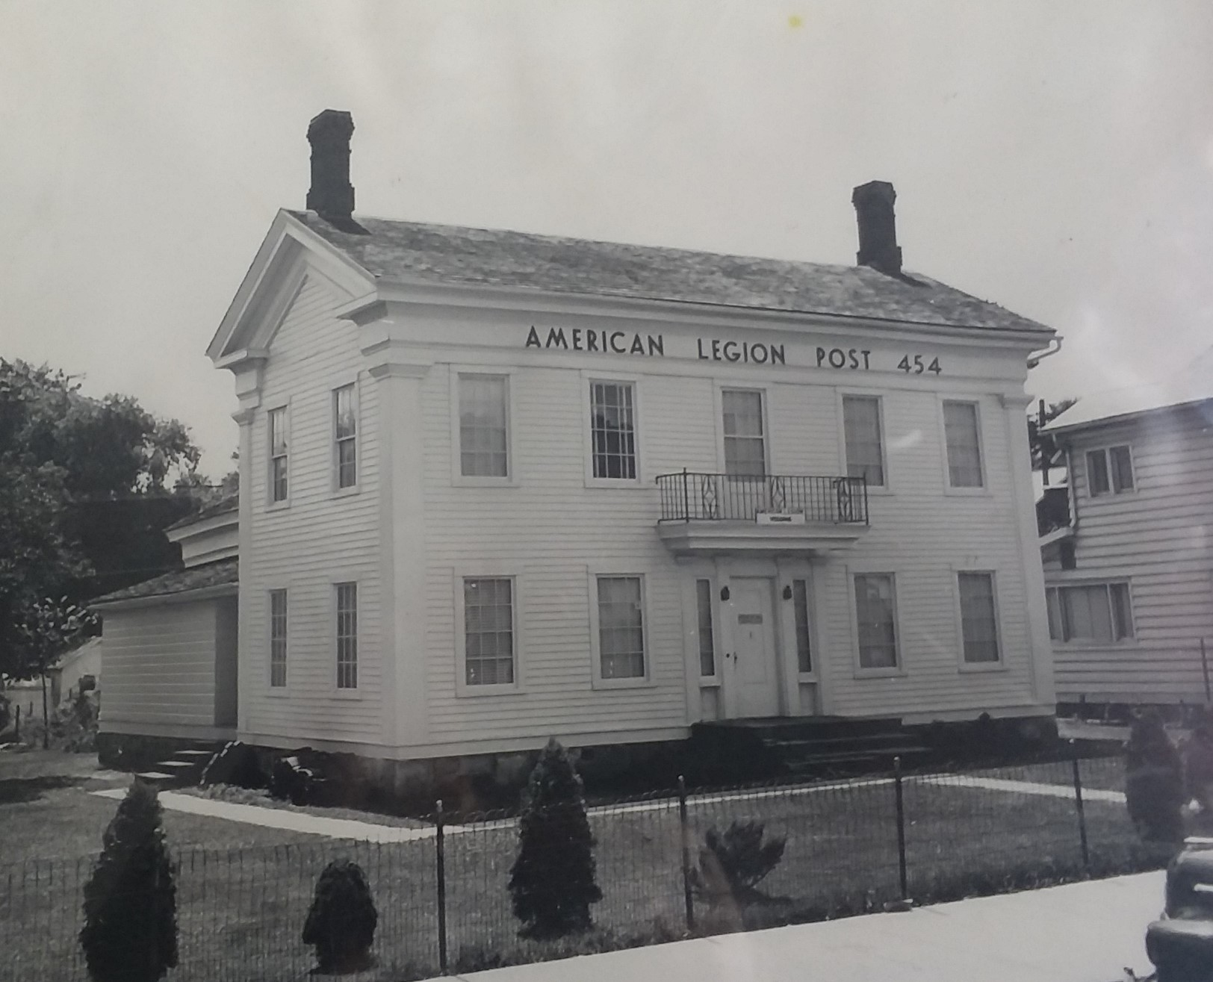

Hello All,
Wow, it’s hard to believe that it’s been almost six months since the last newsletter. I hope this letter finds you all well and prospering, but I know that we have members who are suffering and I hope you will keep them all in your thoughts and prayers. Things have been fast and hectic since then as I’ll describe below.

On March 11, we celebrated the 75th anniversary of the granting of our permanent charter. The Post was full with 85 Legion Family members helping us celebrate. The Auxiliary put on a wonderful meal and we recognized Legionnaires with significant membership milestones, including Newell Chadwick who has 65 continuous years of membership!

Reveille! Reveille! Reveille! All hands heave to and trice up. Sweepers, sweepers man your brooms. Give the ship a clean sweep down fore and aft. Sweep down all lower decks, ladder wells and passageways. Now sweepers. That was for all you Navy folk out there, but at the end of March our ship (or Post) got a clean sweep as a crew of about 15 people showed up and gave her a thorough cleaning from galley (again for you Navy folk) to the bar. The outside got some attention too as the winter’s accumulation of trash got picked up and disposed of.

April 16 was our annual Easter Egg Hunt, held at the high school. The Easter Bunny was there along with over 100 children and their families. 100 dozen eggs were collected in about 10 minutes as they zoomed down the hill picking them up like a Hoover Vacuum. Hours of preparation and egg coloring is over just that quickly. Of course, they hang around a little afterward counting eggs, collecting 50 cent pieces for specially marked eggs and receiving a chocolate bar from one of our Legionnaires.

Part of the March clean-up was to determine things around the Post that we just don’t need anymore. We found enough things that in May we held a rummage sale and got rid of some of those things and made a little extra cash for the Post. It wasn’t a huge windfall, but it beat paying the garbage service to haul the stuff away!

Of course, one of our big and most important events each year is Memorial Day. Again, this year the Legion held our ceremonies at the bridge downtown and Lakeside Cemetery as well as participating in both Leonidas’ and Burr Oak’s ceremonies. We were extremely fortunate this year to have Air National Guard, Colonel Shawn Holtz as our keynote speaker. Colonel Holtz is a 1986 graduate of Colon High School and an A-10, Warthog Pilot with over 4,200 flight hours. He was, at the time, Commander of the 110th Wing and the Battle Creek Air National Guard Base and we were honored that he accepted our invitation to speak.

Around the beginning of May, one of our Legion Members hit the Queen of Hearts Jackpot. The pot had grown to almost $78,000 when they won and they received half of that amount with the other half being earmarked for Veterans Memorial Park. Our first year with this raffle raised nearly $50,000 for the park. This year’s raffle isn’t progressing as quickly. At the time of this writing, the Jackpot is at $8,700 so come on in, buy some tickets and help us get some additional funding so we can make the park a memorial to veterans that we will all be proud of. Speaking of the park, we will soon be selling brick pavers to go in the park. Buy a paver to recognize a veteran important to you or one for yourself.

In June we conducted an honorable disposal of unserviceable American Flags. The Post gathered at the Legion barn and conducted a ceremony to dispose of over 1000 flags that were no longer fitting symbols of our country. For those of you who do not know, there is a receptacle at the front of the Post where you can place unserviceable flags anytime. We also sell new flags if you need a replacement. Just ask the bartender.

Again, this year the American Legion Color Guard led the 4th of July Parade down State Street in Colon. Additionally, we had a float for veterans to ride and throw candy to the kids. The Auxiliary augmented the color guard and had a float of their own. Ox Roast sandwiches sold out by around 3:00 PM and the bar did a booming business. It was a wonderful day celebrating our great country!

SAL members organized and held the Pontoon Poker Run again this year. There were over 40 boats signed up and around 125 people participated. Boats made five stops on Palmer Lake and collected their best poker hand with the winner ending up with a full house! Thanks to SAL members Carl Thornton, Brent Frank, Tim Taylor and Mike Smoker for their hard work on this event that raised over $8,000 for the Post.

For the second year in a row our Post exceeded our membership goal! This year the Legion was joined by the Auxiliary and the SAL in this amazing accomplishment. People are recognizing the wonderful things happening with the Post and see how we add value to the community and assist veterans and they want to be a part of it. The Legion finished the year with 130 members at 110% of goal. The Auxiliary had 97 at 115% of goal and the Sons had a phenomenal 90 or 138% of goal!!!

New officers were installed at the July meeting. Most were returning for another year of duty in their position. I (Brett Johnson) remain the Commander. Brian Reed continues as Vice Commander. David (Buzz) Farrand is still Chaplain as is Richard Persing as Historian and Mike Smoker as Finance Officer. Don Truax re-enlisted for Sergeant-at-Arms and Mike Shirey is our new Post Adjutant.

So, what’s coming up? August will be a hectic month for us, starting with Magic Week this week. We are expecting the town to be, once again, flooded with magicians who all seem to find their way into our bar after the big show at night. We buy a special liquor license for this event so we can be open to the public and bring in enough revenue in this one week to cover all our varied insurance for the year! The Auxiliary also makes a good chunk of change selling food after the show is over.

The Magic City Egg Fest is Saturday, August 13. So, as you read this, if you haven’t gotten your advanced tickets yet, you’ll want to do so. Advanced “Taster” Tickets are available on line at Magiccityeggfest.com or at the bar for only $10. If you wait to get them the day of the event, they will be $15 so get them now. Taster tickets get you into the event, beginning at 11:00 AM in the municipal parking lot behind Omni Credit Union and entitle you to taste all of the ribs, chicken and pizza that you want until 5:00 PM. Don’t come at 1:00, though, and expect to get ribs as they will be gone by then. So, get there early and stay all day. We are still looking for volunteers to help set-up and tear-down.

We have a lot of other events coming up over the course of the fall and winter. Stay up-to-date with everything that is happening at the Post by visiting our website at colonamericanlegion.com. The homepage has “What’s New” which gets updated weekly (well usually) and a calendar with upcoming and recurring events.

As always, our main focus is on veterans. Over the course of the last several months we have assisted veterans in getting to medical appointments, providing funding for unforeseen emergencies and directed veterans to needed resources. Veterans are a proud bunch and are normally hesitant to ask for help, but assisting veterans is why the American Legion was founded. So, if you need help or know of a veteran who needs help contact us.

A NOTE FROM THE SAL COMMANDER:

First, I would love to thank everyone that participated in making our 2nd Sunday of the month Breakfast the hit that it is. With that said, we can always use help and we never turn anyone away. So, if you would like to help, leave a note with contact info for myself or Mike Smoker at the bar. With the breakfast doing so well, we had the opportunity to donate $500 to the Colon HS summer baseball and $1,000 to the 4th of July fireworks celebration (Sparkle).

One major change is coming. Starting with the October breakfast on 10/9 we are going to be changing the hours to 8 AM to 11 AM. Hope to see you at our breakfast

Jim May
SAL Commander

Upcoming Special and Recurring Activities:
October 29, 7:00-??—Halloween Costume Party
November 11—Veterans Day Ceremony
November 12—Member Appreciation Night
December 3—Christmas in Colon—Legion Chili Cookoff
December 17—Children’s Christmas Party
Bingo-Every Monday night. Doors open at 4:00 PM. 1st Game is at 6:00 PM
Queen of Hearts Drawing-Every Saturday night at 7:00 PM
SAL Breakfast-2nd Sunday of the Month, 8:00-11:00 AM
Fish Fry-4th Friday of the Month, 5:30-7:30 PM
Auxiliary Meeting-1st Wednesday of the Month at 7:00 PM
Legion Meeting-1st Thursday of the Month at 7:00 PM
SAL Meeting-2nd Sunday of the Month immediately following breakfast.
All these events and others are also listed on the calendar on our website.

Football Season is coming. The Legion raises the flag at all home football games. If you would like to assist with this, let me know.

I know I just told you how remarkably well we did with membership last year, but now it’s time to focus on this year’s membership. You should have recently received your renewal notice in the mail. Please renew your membership right away and keep us going strong into the coming year.

Finally, I need to let you know that the bar will not be open every Sunday anymore. There just was not enough business to justify remaining open on every Sunday. We will, however, be open on the second Sunday of the month (same day as the SAL breakfast) and will host a Bloody Mary Bar on that day each month beginning at noon. So, 2nd Sunday, Noon to 6:00 PM are the new Sunday bar hours.

As always, I look forward to seeing you around.

Brett Johnson Legion-269-432-9088
Commander Brett-269-251-9894 or brettej@aol.com
https://colonamericanlegion.com

