Snyder-Lewis-Welty
Post 454
Colon Michigan

Hello Everyone,
Well, here we are in the dead of winter. As I’m writing this I’m hearing on the news that Punxsutawney Phil has seen his shadow and we are condemned to another six weeks of winter. However, the flocks of robins and the return of the turkey vultures would lead me to believe otherwise. Regardless, a lot has happened since our last newsletter and I want to get you filled in on the details because spring will be here before you know it.

In August we held the Magic City Egg Fest. This year’s event was a resounding success with 20 teams participating and over 800 people coming out to eat some excellent barbequed ribs, chicken and pizza. The event raised over $21,000 in support of the Legion. Thanks to everyone who worked hard to make this a success, especially SAL Member Tim Taylor who’s leadership in putting on this event was critical. This year will have a bit of a format change as competitors will be able to use any type of lump charcoal grill and won’t be restricted to the Big Green Egg. BYOG-Bring your own grill! With that will come a name change and the event will now be known as the Magic City Grill Fest. Additionally, are moving up the date to June 17. Stay tuned and watch our website for details as we get closer to summer.
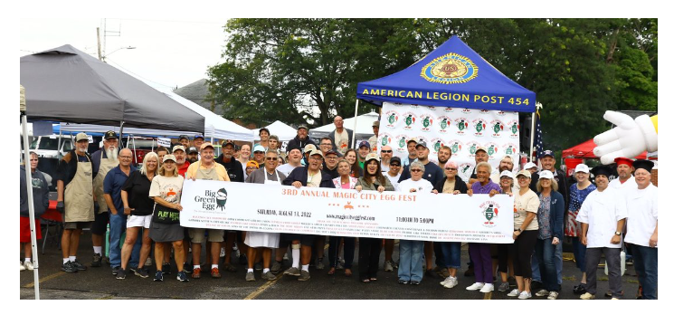

We continue to support the Magi athletic teams. Legionnaires raised the flag at all the home football games including two playoff games as the Magi wracked up a 10-1 season. The SAL donated $800 to the girls’ basketball team to buy basketballs and this month we are hosting Baseball Bingo to help raise funds for the baseball team.
Speaking of the Magi, our school has been a great partner for us. This year we held our Veterans’ Day Program in the high school gymnasium. Students from grade 6 through 12 attended as well as members of the community.
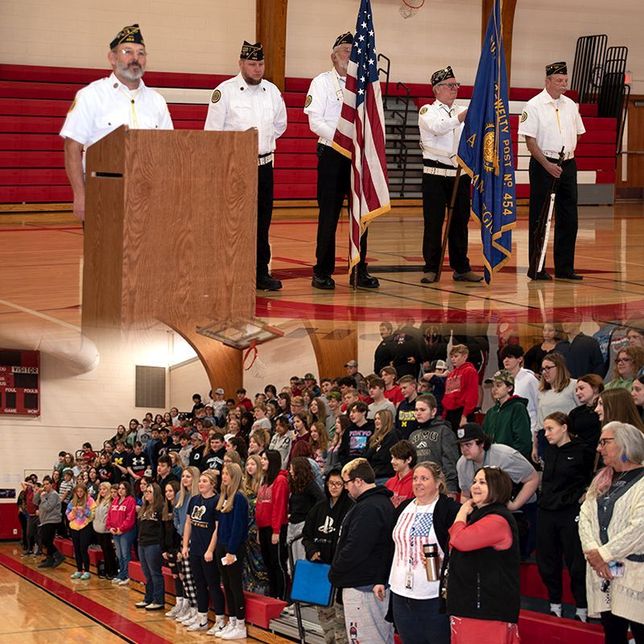

Saturday nights in our canteen is the place to be. Right now, the Queen of Hearts raffle jackpot is about $40,000. Of course, proceeds from that raffle are going to support the Veterans Memorial Park in Colon. We’ve held some great Saturday night events over the past few months including: Halloween Costume Party, Member Appreciation Night, Chili Cookoff as part of Christmas in Colon, an Ugly Sweater Party and a New Year’s Eve Party with DJ Jamin Joe. We’ve got a Mardi Gras Party on the books for February 18 as well as corned beef and cabbage for St. Patrick’s Day.

This year’s sweepstakes for the children’s fund was a huge success. You all were very generous in giving. We raised over $1,400 above expenses of postage and prizes. This year’s winners were: Marilyn Truckey-1st place, Kathy Ludwick-2nd place and Lyman Freeland-3rd place. Part of these proceeds went to pay for the Children’s Christmas Party. This year we had 91 kids come and visit with Santa and receive a gift. The next big children’s event will be our annual Easter Egg Hunt on April 8.
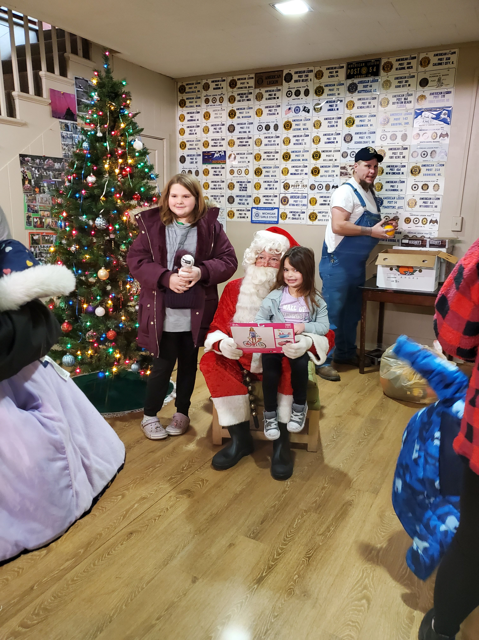

We’ve hired a new cook and food service is better than ever. Fish Frys have started up again on the last Friday of each month and the SAL Breakfasts are still cheap, delicious and all-you-can-eat. They start at 8:00 AM on the second Sunday of each month, followed by our Bloody Mary Bar.

Unfortunately, it hasn’t been all fun and happiness. This is the point were I inform you of the passing of some of our veterans. Since the last newsletter, we have lost Wayne Bielski, Lyle Jeffrey and John Nystrom. We will miss our comrades. At the writing of this letter, we have members who are battling cancer, COVID and other illness. We want to wish them all a speedy recovery and good health in this new year.

So, I’ve told you what we did and a little about some upcoming events but we have a lot more happening between now and the summer newsletter. The first thing coming is the Legion Birthday Party. This will be held on March 4. Cocktails will be from 6:00-7:00 PM with dinner and program beginning at 7:00. There will be a sign-up sheet in the bar. Please sign-up so the Auxiliary knows how many meals to provide. If you plan to come but won’t be in the bar to sign-up, you can call 269-432-9088 and the bartender will put your name on the list.

We’ll have corned beef and cabbage for St. Patrick’s Day starting at 4:00 PM and serving until it is gone. It went fast last time, so don’t wait until 7:00 to try and get some. I’ve already mentioned that the Easter Egg Hunt is April 8 and Magic City Grill Fest is June 17.

Memorial Day, this year, is on May 29. We will have our usual program at the bridge downtown and the cemetery. Many of our members who have participated in this for years are getting older and unable to stand or march any more so I would encourage our younger members (you know 65 and under) to step up and help us continue this very important tradition of honoring our fallen. In addition to the Colon ceremonies, we also support community ceremonies in Leonidas and Burr Oak.

On June 10 we will retire flags that are no longer a fitting symbol of our country. If you have unserviceable American Flags, we have a drop-box in front of the post or you can give them to the bartender.
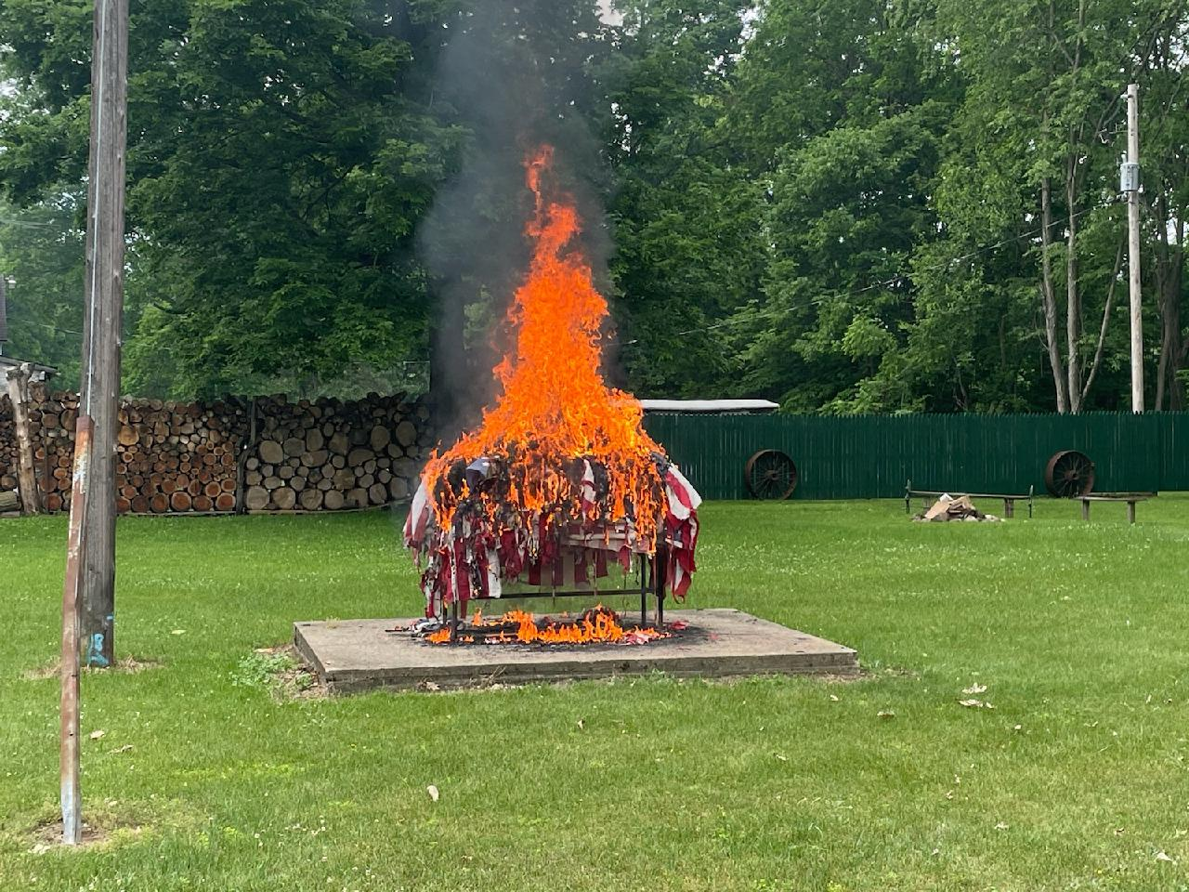

The Pontoon Poker Run will be on July 8 this year. If you have never participated in this event you are missing out on a great time on Palmer Lake. We are expanding the event this year to include up to 45 boats. Contact our event coordinator Carl Thornton to get registered.

Finally, while not something that will happen prior to the next newsletter, the SAL is sponsoring a mini-triathlon this year on July 29. The Legion Full Battle Rattle sprint triathlon is a U.S. Olympic Committee sanctioned event and will include a ½ mile swim, 15.2 mile bike course and 3.1 mile run. To register for the event, go to: https://fullbattlerattle.ticketsocket.com/
All of the aforementioned events and activities require volunteers to make them successful. If you have helped run our events in the past you have my undying gratitude. If you have not, I hope you will consider helping us out on something this year. Many hands make light work, so the saying goes. Hopefully two of those hands will be yours.
We are closing in on our membership goal of 133. To date we are at 115. We need 18 more members to renew their membership prior to May 17 in order to achieve 100%. So, if you have been putting off sending in your dues for this year, please don’t put it off any longer. Let’s close this year out so we can focus on other things. If you know someone who is eligible for membership, bring them in and sign them up. We have 11 new members this year and we still have room for a lot more. Let them know about all the great things your Legion is doing in the community. SAL is at 80 members toward their goal of 91 and the Auxiliary is at 88 of 93. We all made goal last year, let’s do it again.
Lastly, the Post membership voted to start a Legion Riders Chapter. To be a Legion Rider you must be a member of the Legion, Auxiliary or SAL, own a legally registered motorcycle or be the spouse of the owner and be properly licensed and insured. If you are interested in becoming a charter member of this new organization, let me know. If you know someone who rides and would be eligible for membership, encourage them to contact us.
Until our next newsletter, here’s what’s coming up:
Upcoming Special and Recurring Activities:
February 18—Mardi Gras Party
March 4—Legion Birthday Party
March 17—Corned Beef and Cabbage
April 8—Children’s’ Easter Egg Hunt
May 29—Memorial Day Observance
June 10—Flag Retirement Ceremony
June 17—Magic City Grill Fest
July 4—Independence Day Celebration and Parade
July 8—Pontoon Poker Run
July 29—Full Battle Rattle Sprint Triathlon
Bingo-Every Monday night. Doors open at 4:00 PM. 1st Game is at 6:00 PM
Queen of Hearts Drawing-Every Saturday night at 7:00 PM
SAL Breakfast-2nd Sunday of the Month, 8:00-11:00 AM
Fish Fry-Last Friday of the Month, 5:30-7:30 PM
Auxiliary Meeting-1st Wednesday of the Month at 7:00 PM
Legion Meeting-1st Thursday of the Month at 7:00 PM
SAL Meeting-2nd Sunday of the Month immediately following breakfast.

All these events and others are also listed on the calendar on our website: www.colonamericanlegion.com

I look forward to seeing you around.

Brett Johnson
Commander
brettej@aol.com
269-251-9894

